COURSE STRUCTURE & SYLLABUS for M. Tech

VLSI & ES

(Applicable for batches admitted from 2020 - 21)

Godavari institute of Engg & Technology
Approved By AICTE NAAC’A⁺’ Grade Recognized by UCG, U/Sec.2(f)&12(B) Permanent affiliation by JNTUK
GIET Campus, Chaitanya Knowledge city, NH-16, Rajahmundry, East Godavari, A.P.
Tel: +91-883-2484828-31 www.giet.ac.in

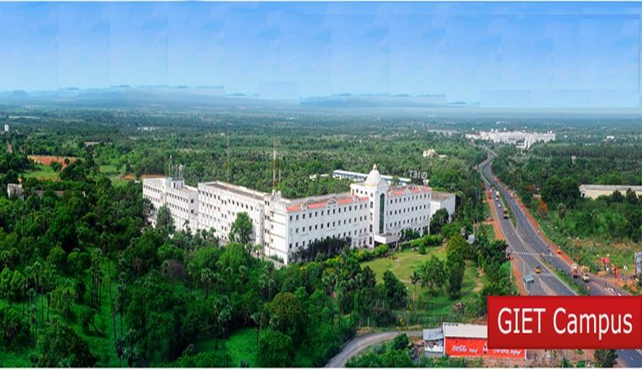

I YEAR I SEMESTER W.E.F Acadamic year 2020-21
Sl. No. | Course Code | Course Category | Subject Title | Periods per week |  |  | C | Scheme of Examination Maximum Marks
 |  |  |  | L | T | P |  | Int. | Ext. | Total
1 |  | PCC | RTL Simulation and Synthesis with PLDs | 3 | 0 | 0 | 3 | 40 | 60 | 100
2 |  | PCC | Microcontrollers Programmable Digital Signal Processors | 3 | 0 | 0 | 3 | 40 | 60 | 100
3 |  | PEC | Professional Elective – I  - VLSI Technology and Design  - VLSI Signal Processing  - CAD of Digital System | 3 | 0 | 0 | 3 | 40 | 60 | 100
4 |  | PEC | Professional Elective – II  - Programming Languages for Embedded Systems  - Advanced Computer Architecture  - Embedded System Design | 3 | 0 | 0 | 3 | 40 | 60 | 100
5 |  | MC | Research Methodology | 2 | 0 | 0 | 2 | 40 | 60 | 100
6 |  | AC | Audit Course -1 | 2 | 0 | 0 | 0 | 40* | - | -
7 |  | PCC | RTL Simulation and Synthesis with PLDs Lab | 0 | 0 | 4 | 2 | 50 | 50 | 100
8 |  | PCC | Microcontrollers and Programmable Digital Signal Processors Lab | 0 | 0 | 4 | 2 | 50 | 50 | 100
TOTAL |  |  |  | 16 | 0 | 8 | 18 | 300 | 400 | 700

I YEAR II SEMESTER W.E.F Acadamic year 2020-21

Sl. No. | Course Code | Course Category | Subject Title | Periods per week |  |  | C | Scheme of Examination Maximum Marks
 |  |  |  | L | T | P |  | Int. | Ext. | Total
1 |  | PCC | Analog & Digital CMOS VLSI Design | 3 | 0 | 0 | 3 | 40 | 60 | 100
2 |  | PCC | Real Time Operating Systems | 3 | 0 | 0 | 3 | 40 | 60 | 100
3 |  | PEC | Professional Elective – III  - System Design with Embedded Linux  - Communication Buses & Interfaces  - Hardware Software Co-Design | 3 | 0 | 0 | 3 | 40 | 60 | 100
4 |  | PEC | Professional Elective – IV  - Physical Design Automation  - SoC Design  - Low Power VLSI Design | 3 | 0 | 0 | 3 | 40 | 60 | 100
5 |  | AC | Audit Course – 2 | 2 | 0 | 0 | 0 | 40* | - | -
6 |  | PCC | Analog & Digital CMOS VLSI Design Lab | 0 | 0 | 4 | 2 | 50 | 50 | 100
7 |  | PCC | Real Time Operating Systems Lab | 0 | 0 | 4 | 2 | 50 | 50 | 100
8 |  | ESC | Mini Project | 0 | 0 | 4 | 2 | 100 | - | 100
TOTAL |  |  |  | 14 | 0 | 12 | 18 | 360 | 340 | 700

II YEAR I SEMESTER W.E.F Acadamic year 2020-21

Sl. No. | Course Code | Course Category | Subject Title | Periods per week |  |  | C | Scheme of Examination  Maximum Marks
 |  |  |  | L | T | P |  | Int. | Ext. | Total
1 |  | PEC / MOOCS* | Professional Elective – V  - IOT and its Applications  - Design for Testability  - Artificial Intelligence | 3 | 0 | 0 | 3 | 40 | 60 | 100
2 |  | OEC / MOOCS* | - Composite Materials  - Cost Management of Engineering Projects  - Machine Learning  - Cyber Security  - Energy Audit Conservation and Management  - Utilization of Electrical Energy  - Operations Research  - Nano Technology | 3 | 0 | 0 | 3 | 40 | 60 | 100
3 |  | PR | Dissertation – I/Industrial Project  (to be continued and evaluated next sem) | 0 | 0 | 20 | 10 | - | - | -
TOTAL |  |  |  | 6 | 0 | 20 | 16 | 80 | 120 | 200
*Students going for Industrial Project/Thesis will complete these courses through MOOCs.

II YEAR II SEMESTER W.E.F Acadamic year 2020-21

Sl. No. | Course  Code | Course Category | Subject Title | Periods per week |  |  | C | Scheme of Examination  Maximum Marks
 |  |  |  | L | T | P |  | Int. | Ext. | Total
1 |  | PR | Project/Dissertation – II | 0 | 0 | 32 | 16 | - | - | -

Audit Course 1&2:
- English for Research Paper Writing
- Disaster Management
- Value Education
- Constitution of India

